Start Talking!
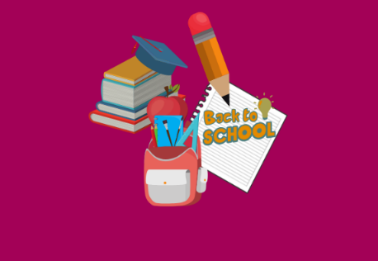
Your child might have worries about the virus, restrictions in place or their education and school.
You can support and help them to think of ways to manage returning to school.
Here are a few examples for you and your family to try which will help with their transition back into school.

- Keeping yourself updated with the information being sent out by school’s parent mail, class dojo’s or the schools website.
- Prepare your child by talking through what to expect, what school have said will happen and what they should do.
- Think about your routine and start preparing you and your child for school mornings.

Never worry alone!
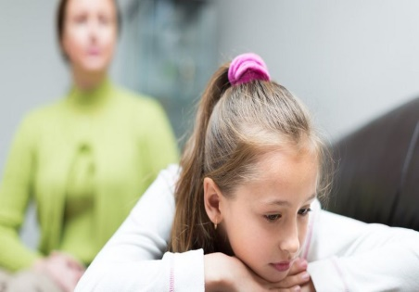
Staff are available to support both yourself and your child with any worries and concerns you may have about returning to school.
Sharing your worries and concerns is the most appropriate way to support your Emotional well-being you can help your child by trying the following:

- Talk to your child about who they would feeling comfortable talking to.
- Send a message through your class dojos to your class teacher indicating the adult/child they feel most comfortable talking to.
- Encourage your child to connect responsibly and safely with their friends before returning to school.
- Communicate any needs your child may have with school as early as possible.


Emotional relaxation
You and your child may have different feelings about coming back to school such as anxiety, excitement, or sadness.
Here are a few techniques for you to try.
- Discuss how you are feeling together, help your child to name their emotions and together realise that these feelings are normal.
- Be prepared for feelings to come out in different ways for e.g.
changes in behaviour, sleep and eating.
- Remember to ’stay calm to bring calm’. Think about how to support
your own feelings.

Here are a couple of links for advice and activities that will support you and your family’s Emotional well-being. Time for Us for activity packs and Family Links website for resources on advice.

